Introduction to Web
How the Internet Works?
Protocols:
A protocol is a set of rules that defines how data is exchanged within or between computers (machines). Or, in other words, a protocol is a convention between parties regarding the information exchange or communication between them.
Examples of such protocols include Internet Protocol (IP), User Datagram Protocol (UDP), Transmission Control Protocol, and so on.
Even you and I can establish a protocol. Let’s say that you and I decide that we will send messages with words that begin with the letter A—then we could say we have established a protocol between us.
HTTP Protocol
HTTP is the acronym for HyperText Transfer Protocol. It was first coined in RFC1945 in 1996. It started with version 1.0, and since then it has evolved, reaching version 3.0.
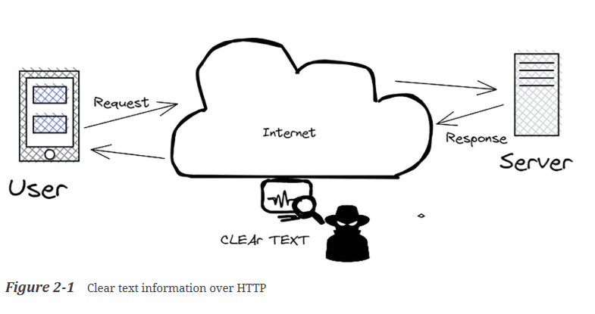
HTTPS Protocol
HTTPS (HTTP Secured) is a version of HTTP where the information traveling between the client and the server is encrypted using a certificate that lives on the web server. That certificate is generated by a certificate authority for a specific domain and or its subdomain. It has an expiration date, which means that from time to time it needs to be renewed.
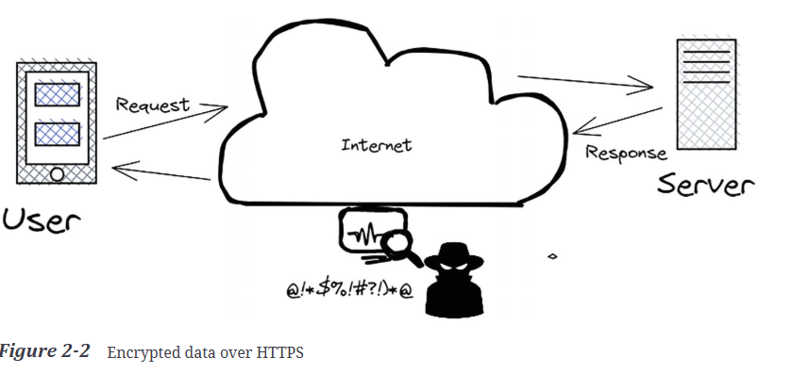
Client-Server Architecture
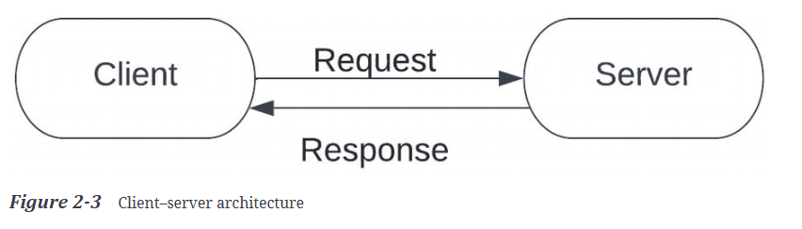
Client : initiates the communication by sending a request
Server : receives requests from clients, processes them, and generates responses back to them.
What is a URL?
URL is an acronym for Uniform Resource Locator
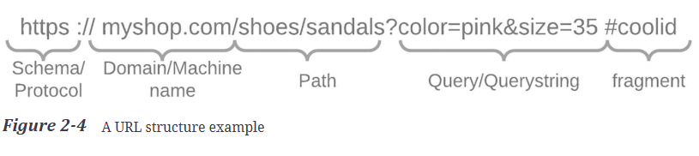
Schema: or protocol shows what is used in terms of transport (ex. HTTP, HTTPS, and FTP).
Domain: specific website
Subdomain: part that prefixes the domain. Businesses use this to split their website based on a criterion.
Path: file path
Query String
The query or the query string is the part in the URL that should have a filtering effect on the results that come from the server as part of the response.
This is made of key=value pair structures, separated by the ampersand (&) symbol. Each such pair has a meaning for the server or the business. Looking at our part example, the string color=pink&size=35 is made of two such pairs:
- color=pink – a parameter named “color” with a value of “pink”
- & – separator
- size=35 – a parameter named “size” with a value of “35”
Fragment
The fragment is the ID of an HTML element in the page, added via the URL.
Request
A request is like an envelope that travels over the network from the client to the server, carrying information to be decoded
- Header – a list of header properties that are sent with the request
- Body – the actual data that is sent in the request, or it might be empty
- HTTP method – showing how to send the request, using one of the categories in the HTTP methods section

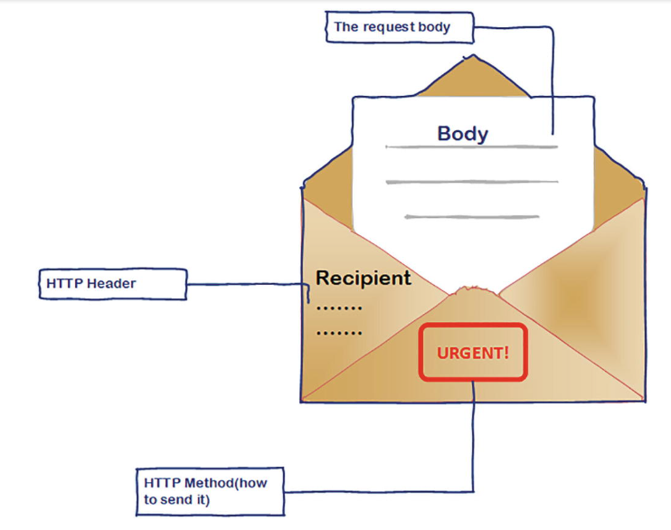
Response
Very much like a request, the response is still like an envelope, but this is sent back to the client as a result of request processing.
- Header – properties that are sent with the response
- Body – the actual data that is sent in the response in the format asked for by the client. It may be empty in specific cases
- Status Code – fits in one of the categories in the status codes section (1XX,2XX,3XX,4XX,5XX)
4XX Client errors , 5XX server errors

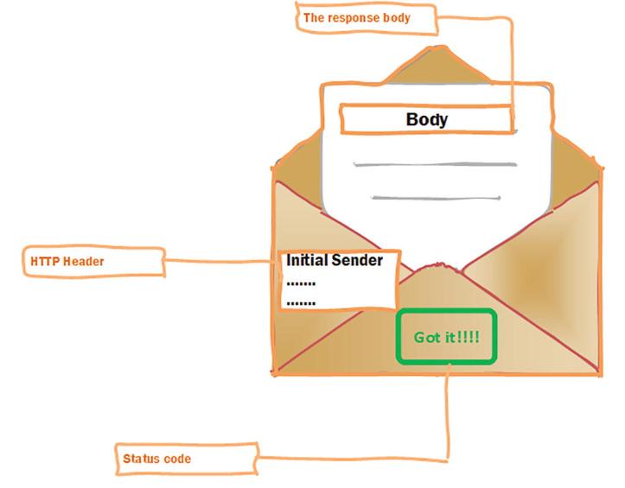
Status
1xx – Informational | informational and are used when the server needs to send an intermediary response for communicating connection status or request progress. The response won’t contain a content body or trailers.
2xx – Success | Success status codes that start with 2xx are indicating that the request has been successfully received and processed.
3xx – Redirects | Redirects are those status codes that indicate that the current URL will redirect or is redirected to another location
4xx – Client Errors | Client errors are the category that shows that the client issuing the request has made something preventing the server from processing it correctly
5xx – Server Errors | Server errors are the category that states that the server won’t be able to process requests.
Cookies
A cookie is a small piece of information with some properties that come from the server. 